Howling Herald

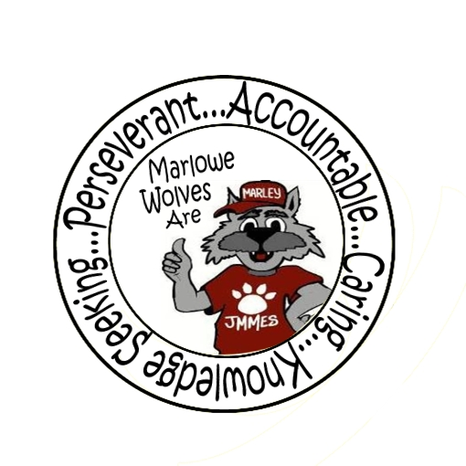



Newsletter for the Families of James M. Marlowe Elementary

Hilda Martin, Principal * Robin Fish, Asst. Principal

5642 Cecelia Drive • New Port Richey, FL • 34652 • (727) 774-8600

**DECEMBER 2016**



**UPCOMING EVENTS**

December 2nd – SAC Meeting 7:40 am

December 8th - Cookies & Milk with Santa 6:00 pm – 7:30 pm

December 15th – Winter Concert 7:00 pm – 8:00 pm

December 15th – Papa John Spirit Night

December 15th – Flag Football Game 1:45 pm

December 19th – 22nd - PTO Holiday Sales during lunch time &

Holiday-O-Gram Sales

December 23rd – January 6th – Winter Break - No School

Happy December Wolf Pack Families,

I’m sure most of you are amazed at how quickly this school year seems to be flying by! We are quickly approaching our mid point mark and students are well on their way with routines, expectations and learning!

As we approach the New Year, we do want to continue to remind you of the importance of on time attendance. Every minute your child is in class learning, the better their chances for success! Please keep supporting your children to be **at school each day and on time**. Tardies and early dismissals can negatively impact student learning and success.

A huge thank you to all the families who are using the car loop and the appropriate areas and procedures for drop off and pick up. For the safety of our students, we continue to remind you that drop off should not be prior to 8:20 and adhering to our arrival and dismissal procedures is critical. Keeping a consistent routine, parking in approved parking spots and waiting for your children in the correct pickup zone maintains a safe and orderly dismissal.

Lastly, I want to thank you and some special staff members for organizing some outstanding events. Your participation and involvement also helped promote a positive school connection and we are grateful. Thank You’s go to:

Mr. Leaver and Mr. O’Neill on an outstanding work on Field Day, Mrs. Chasney and Mrs. Brindley with our Chorus,

and the PTO and Staff for a wonderful Fall Hoedown!

As always we thank you for partnering with us and supporting us in meeting our students’ needs! We wish you and your family a wonderful holiday season and look forward to an incredible 2017! Looking forward to seeing you at Cookies and Milk and Holiday Concerts.

Hilda Martin

**PAPA JOHN NIGHT**



*December 15TH*

Help raise money for the school while having a fun and easy dinner. Order a pizza before heading to the school for the winter concert.

Border Three



**WINTER CONCERT**

***December 15th at 7:00 p.m.***

Chorus and Instrumental Club will perform on the stage in the Marlowe Multi-Purpose Room. This concert is free and open to everyone! Come enjoy a night of wonderful music by our students.

.

**COOKIES AND MILK WITH SANTA**

***December 8th***

***6:00 PM – 7:30 PM***

***Cafeteria***

Join us for a night of holiday fun. Cookies and milk will be provided. Students can make some holiday crafts, write a letter to Santa and make some magical food for Santa’s reindeers. Photos with Santa will be available for $5.00. Holiday-O-Grams will be available for purchase for $1.50. This event is FREE with the exception of the photo with Santa and Holiday-O-Grams. Students must attend with an adult. Accompanying adults must stay with their children throughout the event.





**PARENT INFORMATION**

**ESEA SPAR REPORT**

The Elementary and Secondary Education Act legislation requires that schools provide parents or guardians an annual status report called ESEA School Public Accountability Report. This report is available at the following website:

<http://doeweb-prd.doe.state.fl.us/eds/nclbspar/index.cfm>

The report is also available for review in the front office.

**BOX TOPS**

Keep up the great work of bringing in those box tops. We will be having a box top contest to see what class can collect the most box tops from December 1st to January 29th. The class that has the most box tops will win a classroom surprise! By saving your General Mills box tops, you can help our school. Thank you to all the students for the Box Tops you have been bringing in.

**ACCIDENTS HAPPEN**

Students have accidents on occasion. When possible, the clinic has a change of clothes but not always. We recommend you back a spare pair of clothes in your child’s backpack in case they need in an emergency situation.

**LOST AND FOUND**

Parents, Is your child missing a jacket, sweater or lunch box? Please visit the lost and found. We have many items in lost and found. The lost and found is located inside our Place program. To help make sure your child’s items don’t end up in lost and found, please write their name inside of jackets and lunch boxes.

**November Principal Award Winners**

Kindergarten

Janie Petrulli, Adelyn Volpentesta,

Dalilia Carmichael, Leland Magnuson

1st Grade

Aiden Richie, Leah Candelario,

Melanye Chavez, Cimara Smith

2nd Grade

Neve Miller, Ladareian Roark, Autumn Parsons,

Elias Mujkanovic, Chelsea Vo

3rd Grade

Georgia Brashears, Kenneth Langley

Ciera Candaleria, Kidianez Soto

4th Grade

Alexa Cardoso Gonzalez, Kiley Hetrick,

Jennelle Padilla, Kristal Lara-Baltazar

5th Grade

Roenn Miller, Armonte Leggett,

Angelica Bastida, Ryan Taylor

**PTO NEWS**

PTO would like to thank everyone for coming out to support the Fall Family Hoedown Dance. It was a big success and students and families looked like they were enjoying the night!

**THANK YOU**

***Gia’s Pizza and Joey’s Pizza & Italian Restaurant***

The above community business partners helped support our last two Principal Banquet lunches. Please support our partners in education.

**NEWS FROM THE MUSIC DEPARTMENT**

Mrs. Chasney would like to have everyone put the dates of the upcoming concerts on their calendar!



**Thursday, December 15th during the school day – Chorus and Instrumental Group** will perform for the Marlowe students. Students please wear your black pants and white tops to school this day.

**Thursday, December 15th 7:00 p.m. – Chorus and Instrumental Group** will perform on the stage in the Marlowe Multi-Purpose Room. This concert is free and open to everyone!

**MARLOWE IS ON FACEBOOK**

Like us on Facebook! Upcoming events and information will be posted on Facebook.

<https://www.facebook.com/pages/James-M-Marlowe-Elementary/484263344997743>



*We wish all of our families a happy and safe holiday break and a very*

*Happy New Year!*

***No School***

***December 23rd – January 6th***

***Students return on January 9th***

**District School Board of Pasco County**

Kurt S. Browning, Superintendent of Schools

7227 Land O’ Lakes Boulevard

Land O’ Lakes, FL 34638



# images-3

# ../../../Desktop/Screen%20Shot%202016-11-27%20at%203.34.47%20PM.Border Stars2Macintosh HD:Users:marywhitehead:Desktop:13318214841422065416wolf track-th.pngwolf-head.jpgMacintosh HD:Users:marywhitehead:Desktop:PB-1899J.jpgWolf Standing.jpg

**November Principal Award Winners**

Kindergarten

Jacob Scott, Torrence Jackson,

Ishi Musto, Lucas Rempert

1st Grade

Abby Barna, Hailee Smith,

Jaelynn Kumer, Ryin Wohlert

2nd Grade

Ciera Candleano, Emma Frost, Isabella Wilton,

Joselyn Kelly, Genesis Garrett

3rd Grade

Helena Mann, Alyssa Rey,

Rogelio Perez-Rivera, Kiley Hetrick

4th Grade

Noah Younger, Logan Emminger, Elissa Miller

5th Grade

Kevin Flores, Zayra Rodriguez, Aayah Hosein