Howling Herald

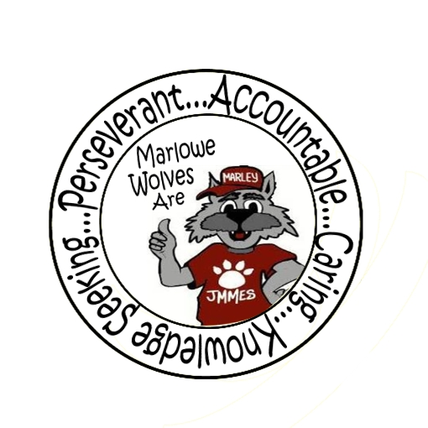



Newsletter for the Families of James M. Marlowe Elementary

Hilda Martin, Principal * Robin Fish, Asst. Principal

5642 Cecelia Drive • New Port Richey, FL • 34652 • (727) 774-8600

**DECEMBER 2017**



**UPCOMING EVENTS**

December 1st - SAC Meeting 7:40 am

December 12th - Cookies & Milk with Santa 6:00 pm – 7:30 pm

December 21st - Flag Football Game 1:45 pm

December 11th - 18th - PTO Holiday Shoppe

December 22rd - January 5th – Winter Break - No School

January 8th - No School – Teacher Planning Day

Happy December Wolf Pack Families,

I’m sure most of you are amazed at how quickly this school year seems to be flying by! We are quickly approaching our mid point mark and students are well on their way with routines, expectations and learning!

As we approach the New Year, we do want to continue to remind you of the importance of on time attendance. Every minute your child is in class learning, the better their chances for success! Please keep supporting your children to be **at school each day and on time**. Tardies and early dismissals can negatively impact student learning and success.

A huge thank you to all the families who are using the car loop and the appropriate areas and procedures for drop off and pick up. For the safety of our students, we continue to remind you that drop off should not be prior to 8:20 and adhering to our arrival and dismissal procedures is critical. Keeping a consistent routine, parking in approved parking spots and waiting for your children in the correct pickup zone maintains a safe and orderly dismissal.

Lastly, I want to thank you and some special staff members for organizing some outstanding events. Your participation and involvement also helped promote a positive school connection and we are grateful. Thank You’s go to:

Mr. Leaver and Mr. O’Neill on an outstanding work on Field Day, Mrs. Chasney with our Orff Club and the PTO and Staff for a wonderful Fall Hoedown!

As always we thank you for partnering with us and supporting us in meeting our students’ needs! We wish you and your family a wonderful holiday season and look forward to an incredible 2018! Looking forward to seeing you at Cookies and Milk.

Hilda Martin

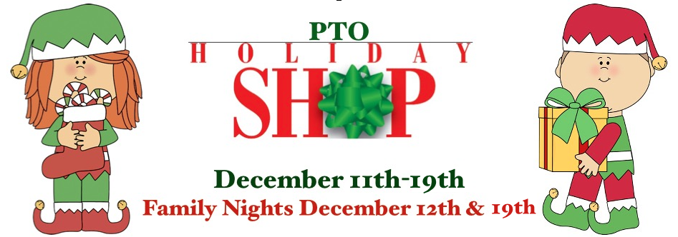

**PTO HOLIDAY SHOPPE**

The PTO will be sponsoring a Holiday Shoppe to give stuents the opportunity to purchase some small gifts for family and friends. Students will have an assigned date to go with their class to shop. The Holiday Shoppe will also be open in the mornings for students to come in with a parent to shop and two family nights on December 12th 5:00 – 6:00 pm and December 19th 3:00 – 6:00 pm.

Border Three



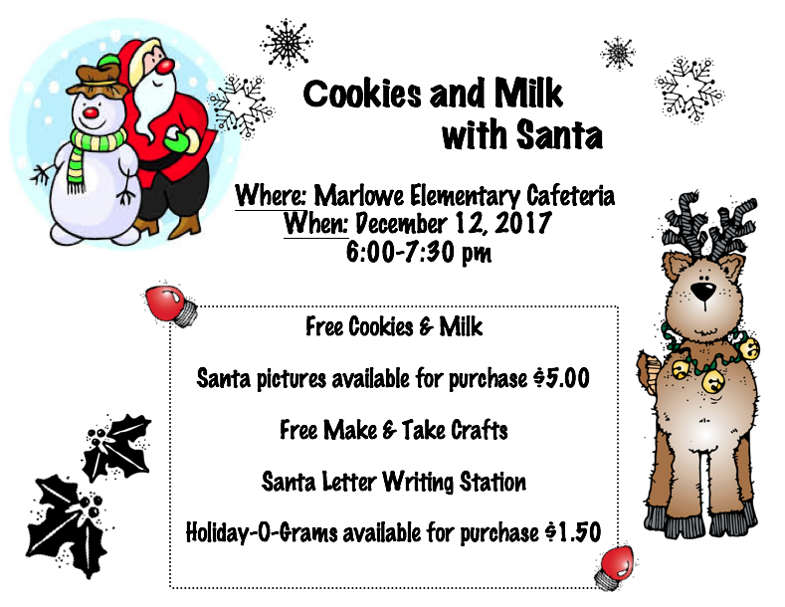

Join us for a night of holiday fun. Cookies and milk will be provided. Students can make some holiday crafts, write a letter to Santa and make some magical food for Santa’s reindeers. Photos with Santa will be available for $5.00. Holiday-O-Grams will be available for purchase for $1.50. This event is FREE with the exception of the photo with Santa and Holiday-O-Grams. Students must attend with an adult. Accompanying adults must stay with their children throughout the event.



**PTO NEWS**

PTO would like to thank everyone for coming out to support the Fall Family Hoedown Dance. It was a big success and students and families looked like they were enjoying the night!

**THANK YOU**

Thank you ***Leaning Tower Pizza*** and ***Carrabba’s*** for sponsoring our last two Principal Banquet lunches. Please support our partners in education. Thank you ***Wal-Mart*** and ***That Little Bakery on Grand*** for supporting our Fall Family Hoedown Dance. Please support their businesses. Partnerships are essential to the successful implementation of many school programs.



**GREAT AMERICAN TEACH-IN**

The Great American Teach In, sponsored by Duke Energy, is a special opportunity for volunteers to share, discuss, and demonstrate their careers with students. Marlowe Elementary students were honored to have a diverse representation of volunteers visit classrooms to discuss their careers. Thank you Busch Gardens, River Ridge High School Robotics Team, Mr. Richarz and Mrs. Miller. The students enjoyed learning about different jobs in the community.

**MARLOWE IS ON FACEBOOK**

Like us on Facebook! Upcoming events and information will be posted on Facebook.

<https://www.facebook.com/pages/James-M-Marlowe-Elementary/484263344997743>



***No School***

***December 22rd – January 8th***

***Students return on January 9th***

*We wish all of our families a happy and*

*safe holiday break and a*

*very Happy New Year!*

**District School Board of Pasco County**

Kurt S. Browning, Superintendent of Schools

7227 Land O’ Lakes Boulevard

Land O’ Lakes, FL 34638



**PARENT INFORMATION**

**ESEA SPAR REPORT**

The Elementary and Secondary Education Act legislation requires that schools provide parents or guardians an annual status report called ESEA School Public Accountability Report. This report is available at the following website:

<http://doeweb-prd.doe.state.fl.us/eds/nclbspar/index.cfm>

The report is also available for review in the front office.

**BOX TOPS**

Keep up the great work of bringing in those box tops. We will be having a box top contest to see what class can collect the most box tops from December 1st to January 29th. The class that has the most box tops will win a classroom surprise! By saving your General Mills box tops, you can help our school. Thank you to all the students for the Box Tops you have been bringing in.

**ACCIDENTS HAPPEN**

Students have accidents on occasion. When possible, the clinic has a change of clothes but not always. We recommend you back a spare pair of clothes in your child’s backpack in case they need in an emergency situation.

**LOST AND FOUND**

Parents, Is your child is missing a jacket, sweater or lunch box? Please visit the lost and found. We have many items in lost and found. The lost and found is located inside our Place program. To help make sure your child’s items don’t end up in lost and found, please write their name inside of jackets and lunch boxes.

**November Principal Award Winners**

Kindergarten

Jaterrion Lee, Luis Perez-Morales,

Jovana Travoric, Isabella Watson

1st Grade

Ashley Englehart, Karter Hunter, Olevia Reis,

Adreanna Dunn, Haydar Byish

2nd Grade

Littsie Baxcajay, Jaden Molina,

Olivia Sanders

3rd Grade

Dereck Torres, Hailee Smith, Isabella Barnard,

Beyonce Miranda, Esmeralda Rubio

4th Grade

Christopher Cruz-Hernandez, Aliyah Madera,

Kennedy Rosas-Rogers

5th Grade

Halaya Mitchell, Victoria Miller,

Allie Sannoh, Jessica Palma-Hernandez

# images-3

# ../../../Desktop/Screen%20Shot%202016-11-27%20at%203.34.47%20PM.Border Stars2Macintosh HD:Users:marywhitehead:Desktop:13318214841422065416wolf track-th.pngMacintosh HD:Users:marywhitehead:Desktop:PB-1899J.jpgWolf Standing.jpg

**November Principal Award Winners**

Kindergarten

Jacob Scott, Torrence Jackson,

Ishi Musto, Lucas Rempert

1st Grade

Abby Barna, Hailee Smith,

Jaelynn Kumer, Ryin Wohlert

2nd Grade

Ciera Candleano, Emma Frost, Isabella Wilton,

Joselyn Kelly, Genesis Garrett

3rd Grade

Helena Mann, Alyssa Rey,

Rogelio Perez-Rivera, Kiley Hetrick

4th Grade

Noah Younger, Logan Emminger, Elissa Miller

5th Grade

Kevin Flores, Zayra Rodriguez, Aayah Hosein