Howling Herald
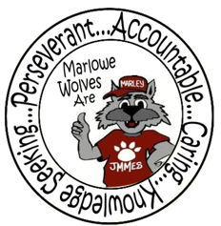



Newsletter for the Families of James M. Marlowe Elementary
Hilda Martin, Principal * Robin Fish, Asst. Principal
5642 Cecelia Drive • New Port Richey, FL • 34652 • (727) 774-8600

MARCH 2017

 FSA TESTING
FSA testing will begin on March 28th and run through May 2nd for students in grades 3, 4 and 5. Please keep in mind the following tips in order to give your child his or her best opportunity for success:
- Encourage a good night’s sleep
- Dress comfortably
- Encourage your child to read every question carefully and eliminate the known wrong answers if a question is difficult

Testing will begin each morning at 8:50, so please make every effort to arrive at school on time. It is important to note that if a student begins a session and needs to leave campus without finishing (due to an appointment, illness, etc.), he or she will not be allowed to complete that session. Please make every effort to schedule appointments on dates that are not designated as FSA testing days. Testing dates are as follows:

March 28th & 29th April 10th & 11th
FSA Reading - Grades 3 FSA Math– Grade 4
April 12th & 13th April 17th & 18th
FSA Math – Grade 3 FSA Reading – Grade 4 April 19th & 20th April 24th & 25th
FSA Reading – Grade 5 FSA Math – Grade 5
May 1st & 2nd
FCAT Science – Grade 5
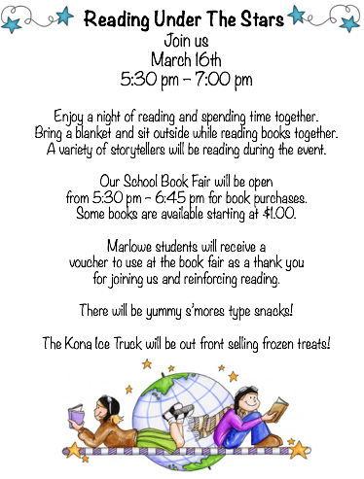

UPCOMING EVENTS
March 2nd – STEM Make n Take 3:00 – 5:00 pm
March 3rd – SAC Meeting – 7:40 am
March 6th – 10th National School Breakfast Week
March 16th - Reading Under The Stars – 5:30 pm
March 17th - No School – Teacher Planning Day
March 20th – March 24th - Spring Break – No School
April 3rd – Report Cards



HEAD START & EARLY HEAD START APPLICATION DAYS

No appointment needed! Each family must meet in person with a staff member in order to apply for Head Start/ Early Head Start. Head Start/Early Head Start is not a first come first served program. Please expect to be at an application day location for your face-to-face interview for at least 30 minutes or more.
District School Board Complex, (Portable 23) 8:30 a.m. - 3:00 p.m.
7227 Land O’ Lakes Blvd. (Hwy 41) Land O’ Lakes 34638
March 1 and May 4
Metropolitan Ministries Outreach Center 9:00 a.m. - 3:00 p.m.
3214 US Highway 19 Holiday 34691
March 16, April 26, May17

At the time you submit the application, you must have the minimum items: Proof of birth for all applicants, Proof of Guardianship/Kinship, Proof of residency in Pasco County, Proof of income, Applicants social security card, WIC documentation, Any disability documentation, Documentation of pregnancy if applicant is an expectant mother. Details on documentation can be found at: http://www.pasco.k12.fl.us/ecp/required_documents

BOX TOPS
Congratulations to Mrs. Shea’s class for having the most box tops in December, January & February. They have earned an ice cream party! Keep those box tops coming.


ART NEWS
Selected students were able to display their artwork at the Pasco County Fair. CONGRATULATIONS to the following students for being selected for the art show:
Kiley Collins, Emma Parra, Noah Younger,
Irenes Martinez-Lopez, Milka Escalante, Zullymar Emigdio, Alicia Perez, Jaelynn Davis-Kumor, Isabella Diaz,
Luciana Duke-Willey




FLORIDA’S 2016-2017 ESE PARENT SURVEY
We need your help to make Florida’s 2016-2017 ESE Parent Survey a record success. Each year, the Florida Department of Education (FDOE) surveys parents of children with an individual educational plan (IEP) to determine how well your child’s school is partnering with you and promoting your involvement in your child’s education. All states must collect this data as part of their State Performance Plan, as required under the Individuals with Disabilities Education Act (IDEA) Make Your Voice Heard! The web-based survey is now open. You can complete the survey online at: http://www.esesurvey.com or request a paper survey from your child’s school. Your feedback is important in helping the state and local school systems continue improving educational programs for children with special needs. Thank you!
Necesitamos su ayuda para hacer de la Encuesta ESE 2016-2017 para padres en Florida un gran éxito. Cada año el Departamento de Educación de Florida (FDOE) encuesta a los padres de niños que tienen un plan educativo individualizado (IEP) para determinar cómo la escuela se relaciona con usted y cómo promueven su participación en la educación de su niño(a). Todos los estados deben obtener esta información como parte de su Plan de Desempeño del Estado, según lo requiere la Ley de Educación de Personas con Discapacidades (IDEA). ¡Que se oiga su voz! Puede contestar la encuesta visitando: http://www.esesurvey.com o solicitar la encuesta en papel en la escuela de su niño. Su opinión es importante para ayudar a los sistemas escolares locales y estatales a seguir mejorando los programas educativos para los niños con necesidades especiales. ¡Gracias!

ORDER YOUR YEARBOOK
It’s that time of year to order your Marlowe Elementary yearbook. Order forms are available in the office.
Yearbooks are $16.00.
Order now, so your child won’t miss out when the yearbook is distributed! As an adult, you know how important school memories become. Don’t let your child’s memories fade; make sure you get a yearbook now!

SPRING BREAK
Spring Break is March 20th – March 24th. Students return to school on March 27th. There is no school on March 17th for teacher planning. We hope you enjoy your break!

BOOK FAIR
The Book Fair will be March 13th – 16th. Information will be coming home for the book fair. Extended hours will be available during the Reading Under The Stars.

THANK YOU
Partnerships are essential to the successful implementation of many school programs. Thank you to the following partners in education for their support of our school. Both the school and partners benefit from the cooperative endeavors by sharing resources that promote learning and overall school improvement. Thank you to the following for their support:
Carrabba’s Cracker Barrel
Please support our partners in education!

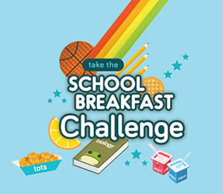

NATIONAL SCHOOL BREAKFAST WEEK
March 6th – 10th is National School Breakfast Week. Take the Breakfast Challenge. Flyers will be coming home with each day’s activities. On Friday, March 10th, parents are invited to have breakfast with your child(ren) from 8:15 am- 8:35 am. Adults $1.75, Non student child $1.35. Please plan to join us.


7227 Land O’ Lakes Boulevard
Land O’ Lakes, FL 34638

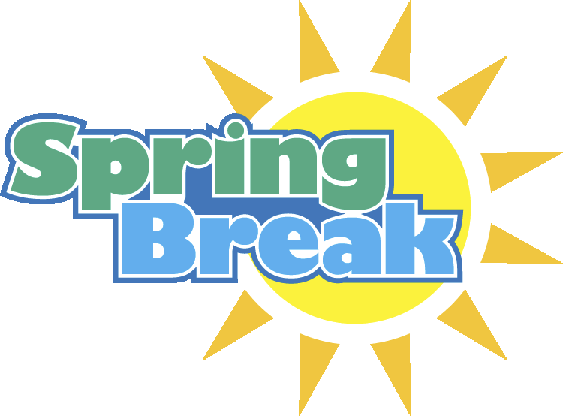






February Principal Banquet Students

Kindergarten
Rylan Medrano, Kiana Batchelor,
Cole Westrich, Sam Sannoh

1st Grade
Camille Kelly, Lupita Juan
Ariana Mayar, Irenes Martinez-Lopez

2nd Grade
Alex Sandlin, Riley Schmidt, Reegan Miller,
Dylan Overend, Benjamin Desposito

3rd Grade
Nicole Crespo-Mormontoy, Cayden Cooper,
Leah Elmore, Juan Massanet

4th Grade
Alyssa Rey, Amir McFarlan,
Julie Harper, Leylah Atley-Desandro

5th Grade
Esmerai Mendoza, Alberto Cruz-Espino
Ashley Maye, Ana Burnett

