Howling Herald

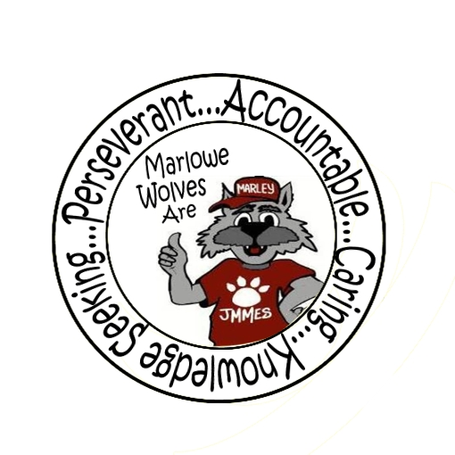



Newsletter for the Families of James M. Marlowe Elementary

Hilda Martin, Principal * Robin Fish, Asst. Principal

5642 Cecelia Drive • New Port Richey, FL • 34652 • (727) 774-8600

**NOVEMBER 2016**



**FALL FAMILY HOEDOWN DANCE**

***November 10th***

***6:00 PM – 7:30 PM***

***Cafeteria***

***Admission $1.00 per person***

Join us for a night of family fun. Food & drinks for sale and fun games ranging in cost from 50 cents to $1.00! Pre-admission and coupons will be available November 7th – 9th in the morning outside the front office. Cash only. This event is only for Marlowe students, their younger siblings and parents/guardians. Middle and High school aged students are not permitted. Accompanying adults must stay with their children throughout the dance.



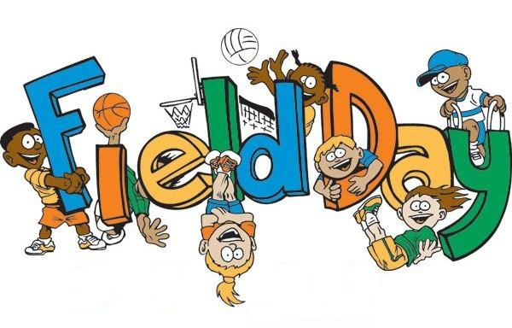

**FIELD DAY**

*November 18th*

*9:00-11:00 a.m. – Primary*

*12:00 -2:00 p.m. – Intermediate*

Please make sure students are dressed properly for Field Day. Students should be in sneakers. Please apply sunscreen before they leave home. There will be some activities that involve water. You may send an extra dry shirt with them in their backpacks. Students may wear hats while they are outside. We are looking forward to a fun filled field day.



**GREAT AMERICAN TEACH-IN**

NOVEMBER 16th

Sponsored by Duke Energy, this is a special opportunity to visit and share a hobby or special talent, talk about your work, plan an activity, or read a book to your child’s class. You may choose to spend an hour or stay the whole day. Please contact the school or your child’s teacher if you would like to participate. Be part of it!

**UPCOMING EVENTS**

November 4th  – SAC Meeting – 7:40 am Media Center

November 8th – Flag Football starts

November 10th – Family Hoedown Dance 6:00 pm – 7:30 pm

November 16th – Great American Teach-In

November 17th – McWolf Night – 4 -7 pm Southgate

November 18th – Progress Reports

November 18th – Field Day

Primary 9:00-11:00 Intermediate 12:00–2:00

November 21st - 25th – Thanksgiving Break – No School

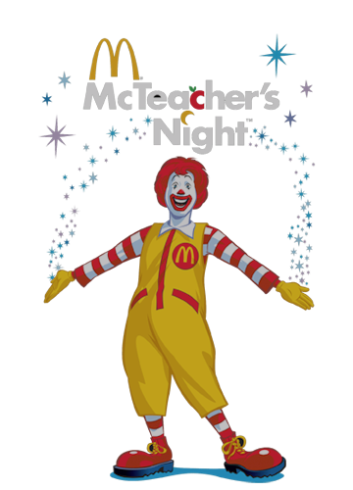

**McWOLF NIGHT**

We will be having our next McWolf Night on November 17th at Southgate Plaza on US Highway 19 from 4:00-7:00 pm. Come out for dinner and help support the school. Even if you aren’t able to come in and have dinner, you can still help by going through the drive through.



**FLORIDA PARENT INVOLVEMENT**

**IN EDUCATION MONTH**

November is ***Family Engagement in Education Month***Family Involvement in a child’s learning is critical to student success from preschool through college and sets the foundation for preparing Florida’s students to be life-long learners and meaningful contributors to society. Research indicates that there is a direct correlation between the high expectations and positive contributions of a child’s parents and high student achievement.

Marlowe Elementary School promotes parent involvement by engaging families in a variety of activities each month. Check the newsletter, marquee and child’s backpack for information on how you can be involved!

**MESSAGE FROM THE SCHOOL NURSE**



Just like you check your child’s homework, check their hair. What can you do if someone in your family gets lice? Check everyone in the house, remove all lice and nits using a special nit comb, place stuffed animals in a plastic bag for several days, wash combs and brushes in hot water, wash bed linens, towels and blankets on the hottest setting and use approved products only to treat for lice. The most effective means of removing lice and eggs without the use of chemicals is to wet the hair, apply conditioner and comb through the hair in sections with a metal comb, such as the Terminator or LiceMeister. Research shows that the hair must be combed and checked for nits every day for 2 weeks to stop the life cycle.

Here are a few Lice Facts:

*Lice cannot live without human contact for more than a day.

*Lice cannot stay alive in schools or on school buses over weekends because they cannot live without human contact for more than a day.

*Lice cannot fly or jump.

*Lice prefer to stay in the hair, not the environment.

*Lice do not cause disease.

*Pets do not get head lice.



**PTO NEWS**

PTO would like to thank everyone for coming out to support the October McWolf Night. It is great to see families enjoying these events! Please plan on attending the next McWolf night on November 17th at Southgate and the Family Hoedown Dance on November 10th from 6:00 pm – 7:30 pm.

**THANK YOU**

***A BIG Thank You to***

***Leaning Tower Pizza and Gia's Pizzeria***

They sponsored our September & October Principal’s Banquet. The kids really enjoyed their special lunch! Partnerships are essential to the successful implementation of many school programs. Please support our partners in education.

**NEWS FROM THE MUSIC DEPARTMENT**

Mrs. Chasney would like to have everyone put the dates of the upcoming concerts on their calendar!



**Wednesday, December 15th during the school day – Chorus and Instrumental Group** will perform for the Marlowe students. Students please wear your black pants and white tops to school this day.

**Wednesday, December 15th at 7:00 p.m. – Chorus and Instrumental Group** will perform on the stage in the Marlowe Multi-Purpose Room. This concert is free and open to everyone!

The **Recorders** will be available for purchase. Mrs. Chasney will be sending information home soon.

**MARLOWE IS ON FACEBOOK**

Like us on Facebook! Upcoming events and information will be posted on Facebook.

<https://www.facebook.com/pages/James-M-Marlowe-Elementary/484263344997743>



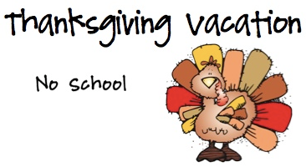

**District School Board of Pasco County**

Kurt S. Browning, Superintendent of Schools

7227 Land O’ Lakes Boulevard

Land O’ Lakes, FL 34638



# wolf-head.jpgMacintosh HD:Users:marywhitehead:Desktop:13318214841422065416wolf track-th.pngBorder Stars2Macintosh HD:Users:marywhitehead:Desktop:PB-1899J.jpgWolf Standing.jpg

**October Principal Award Winners**

*Kindergarten*

Hailey Trejo-Hernandez, Olevia Reis

Madison Embry, Brooklynn Valentine

*1st Grade*

Michael Avent, Kylee Tybor,

Nathaniel Ehrke, Katelin Collova

*2nd Grade*

Zullymar Emigdio, Ethan Hickman, Arissa Hosein

Jaelynn Davis-Kumor, Rihanna Haney

*3rd Grade*

Logan Hartman, Anna Parra,

Monserrat Lara-Escalant, Quentin Swisher

*4th Grade*

Cody Dlugosz, Chance Britt, Peyton Young

*5th Grade*

Jaden Woodward, Nic Greer,

Zac Greer, Danny Dahn

November 21st – 25th