Howling Herald

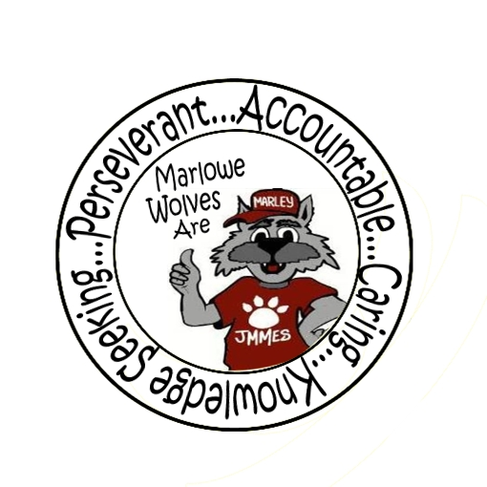

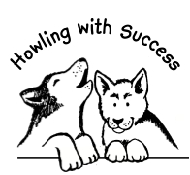

Newsletter for the Families of James M. Marlowe Elementary

Hilda Martin, Principal * Robin Fish, Asst. Principal

5642 Cecelia Drive • New Port Richey, FL • 34652 • (727) 774-8600

**OCTOBER 2017**

**A MESSAGE FROM THE NURSE**

Dear Parents:

Health Screenings and Hearing Screenings will be conducted on Tuesday, November 6, 2017 at Marlowe Elementary School. These screenings are required by Florida statutes.

Kindergarten: Vision& Hearing

First Grade: Vision, Ht/Wt/BMI, Hearing

Third Grade: Vision, Ht/Wt/BMI

New students to Florida in grades 2, 4, & 5: Vision.

You will be notified of the results of the vision screening *only* if medical follow up is necessary. These screenings do not replace your child’s need for regular health care and check ups. If you do not want your child to participate in screening, you must send in a written request for exclusion at least one week before the screening date listed above. If your child wears eye glasses please make sure that they bring then to school on that date. Also you may visit the following web site to calculate your childs body mass index.

http://apps.nccd.cdc.gov/dnpabmi/calculator.aspx

Thank you in advance for your cooperation.

**FLU SHOTS AVAILABLE**

There will be Flu Vaccines available for students on October 6, 2017. Students must have the form completed, signed and returned to participate. Forms were sent home. You can get more information at:

http://www.pasco.k12.fl.us/ssps/health

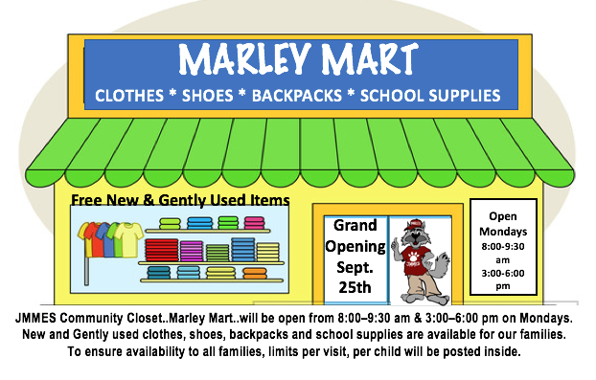

**STAY CONNECTED THROUGH FACEBOOK**

Like us on Facebook! Upcoming events and information will be posted on Facebook.

<https://www.facebook.com/pages/James-M-Marlowe-Elementary/484263344997743>



**UPCOMING EVENTS**

October 6th - SAC Meeting – Media Center 7:40 am

October 10th - McWolf Night State Road 54 from 5-7 pm

October 12th - Fundraiser Due

October 13th - School Pictures

October 16th - No School – Teacher Planning Day

October 26th – PTO Trunk or Treat

October 23rd-27th Red Ribbon Week

October 23rd-27th Boo Gram Sales



**McWOLF NIGHT**

PTO will be sponsoring McWolf Family Nights at McDonald’s throughout the school year. Take a break from cooking and support the school at the same time. Our next McWolf Night will be on October 10th from 5:00-7:00 pm at the McDonald’s on State Road 54. Even if you are unable to come in and have dinner, you can go through the drive thru. All proceeds go directly back into the classrooms. This months funds raised will benefit the Kindergarten classes.

**You must bring the flyer or tell them you are with Marlowe Elementary to earn the school money!**

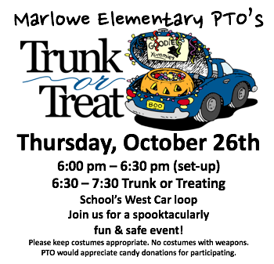

**SCHOOL SUCCESS PLAN**

The School Success Plan (SUP) contains a vivid description of the goals, objectives and strategies that identify the beliefs and values shared by all employees to meet requirements of Florida Statute title XLVIII of the K-20 Education code (Section 16). In addition, it addresses issues relative to budget, training, instructional technology/technology, staffing, student support services, school safety and discipline strategies and is based on an analysis of student achievement data, and school performance data. Each School Advisory Council assists in the preparation and evaluation of the school’s improvement plan. Parents are welcome to review our 2017-2018 School Success Plan, which is available upon request in the front office. Also available in the office is the schools Parent Involvement Plan (PIP) for review.

**PARENT INFORMATION**

**Parental Notification – Out-of-Field Instructional Personnel –** Individuals who are teaching out-of-field are certified in at least one area and are qualified to teach but are required to take additional course work or testing to add a coverage/endorsement to their certificate. The state also requires a teacher to take coursework/inservice towards an English to Speakers of Other Languages (ESOL) endorsement, when the teacher is the primary language arts provider and/or reading teacher for an ESOL student.

James M. Marlowe Out-of-Field for NHQ are Ms. Erbs, Ms. Kans, Mr. Manley, Mrs. Rockwell-Stoler and Mrs. Ricketts Palmer who are working on their ESOL endorsement.

Los maestros que enseñan fuera de su campo están certificados en por lo menos un área, y están calificados para enseñar, pero necesitan tomar cursos adicionales o pruebas para ampliar la cobertura/endoso de su certificado. Cuando el maestro es el proveedor primario de enseñanza de Artes del Lenguaje y/o el maestro de lectura de un estudiante ESOL, el estado también requiere que el maestro tome cursos/servicio interno para el endoso de Inglés para Personas que Hablan Otros Idiomas (ESOL).

Los siguientes maestros han estado de acuerdo en trabajar para obtener el endoso de ESOL: Ms. Erbs, Ms. Kans, Mr. Manley,

Mrs. Rockwell-Stoler and Mrs. Ricketts Palmer

**PARENT RESOURCES**

Did you know that Marlowe Elementary School has a Parent Resource Area? Have you ever wished you had information on a subject regarding parenting, education or other topics? Inside of our new Marley Mart is a resource center just for parents. Parents are welcome to come review materials or check them out. Stop in the office and we can take you back anytime and take a look.

**PARENT INVOLVEMENT POLICY**

In your first day packets, you received our Parent Involvement Policy Brochure. Our full Parent Involvement Plan is available for review in the front office. The District Parent Involvement Plan is also accessible on the district website at:

[www.pasco.k12.fl.us](http://www.pasco.k12.fl.us)

**THANK YOU**

Partnerships are essential to the successful implementation of many school programs. Thank you to the following partners in education for their support of our school. Please support our partners in education.

***The ToyMakers, Wal-Mart, Gia’s Pizzeria, McDonald’s,***

***Winn-Dixie***

September Principal Banquet Student

**Kindergarten**

Emma Jones, Juliana Santa-Martinez

Abigail Madera, Olivia Brown

**1st Grade**

Jaycob Valle, Alietz Torres, Levi Novak

Isabella Inman, Grace Brashears

**2nd Grade**

Katelin Collova, Jacob Scott

Elizabeth Wilton, Lupita Hernandez

**3rd Grade**

Kamryn Hunter, Carlos Lopez, Zullymar Emigdio

Aubreionna Shawley, Torrihana Robinson

**4th Grade**

Drew Novak, Hanna Schweighofer,

Jaylize Ramos

**5th Grade**

Alexis Flores, Demaris Williams

Denhley Zonga Maye, Natasa Sorak

PIRC

The Florida Parental Information and Resource Center (Florida PIRC) at the University of South Florida is funded by the U.S. Department of Education. The goals of this center are to:

*Improve parental involvement in education so Florida’s students are better prepared to enter school

*Increase students’ academic achievement

* Promote family involvement in education through partnerships between The Florida Parent Information Resource Center of FND (PIRC) and schools, parents, other organizations, agencies, parent centers, and community-based family partners through technical assistance and in-service training materials and trainings for educators and families

* Provide information, training, and support for families and educators to:

- Increase families awareness of education issues

- Increase educators' awareness of the issues that impact family involvement for at-risk, minority, or hard-to-reach families

- Increase the numbers and types of partnerships between parents and schools

Families and schools may access a broad range of information and resources by visiting the Florida PIRC at the University of South Florida (<http://www.floridapartnership.usf.edu/default.htm>)

Florida PIRC Parent Notifications may be viewed in English at [http://www.floridapartnership.usf.edu/documents/parent_notification/PIRC_Parent_Notification_English_2010_0409.pdf](http://www.floridapartnership.usf.edu/documents/parent_notification/PIRC%20Parent%20Notification%20English_2010_0409.pdf) and in Spanish at [http://www.floridapartnership.usf.edu/documents/parent_notification/PIRC_Parent_Notification_Spanish_2010_0409.pdf](http://www.floridapartnership.usf.edu/documents/parent_notification/PIRC%20Parent%20Notification%20Spanish_2010_0409.pdf) .

Parental Information and Resource Centers were created under No Child Left Behind / Elementary and Secondary Education Act.

El Centro de Información y Recursos para Padres de Florida (Florida PIRC) en la Universidad del Sur de Florida (USF) y el Centro de Información y Recursos para Padres de Florida (Florida PIRC) de la Red de Familias sobre Discapacidades (FND), son centros previamente subvencionados por el Departamento de Educación de los Estados Unidos. Sus metas son:

* Incrementar la participación de los padres en la educación, para que los estudiantes de Florida estén mejor preparados para su ingreso a la escuela

* Incrementar los logros académicos de estudiantes

*Promover la participación de las familias en la educación, mediante relaciones de trabajo conjunto entre el Centro de Información y Recursos de Florida (PIRC) de FND y las escuelas, padres, otras organizaciones, agencias, centros para padres y asociados de las familias en la comunidad, a través de la asistencia técnica, materiales para entrenamientos de servicio, y entrenamientos para educadores y familias

*Proveer información, entrenamientos y apoyos a familias y educadores para:

- Incrementar la conciencia en las familias sobre temas educacionales

- Incrementar la conciencia en los educadores sobre temas que afecten la participación de las familias en riesgo, de minorías y difíciles de alcanzar

-Incrementar el número y tipos de relaciones de trabajo conjunto entre padres y escuelas.

Las familias y escuelas pueden tener acceso a una amplia gama de información y recursos, visitando el PIRC de Florida en la Universidad del Sur de Florida (USF) (<http://www.floridapartnership.usf.edu/default.htm>) y el PIRC de Florida en la Red de Familias sobre Discapacidades (<http://www.fndfl.org/projects/pirc/index.asp>).

Las notificaciones a padres de los PIRC de Florida pueden verse en inglés en: [http://www.floridapartnership.usf.edu/documents/parent_notification/PIRC_Parent_Notification_English_2010_0409.pdf](http://www.floridapartnership.usf.edu/documents/parent_notification/PIRC%20Parent%20Notification%20English_2010_0409.pdf), y en español en:

[http://www.floridapartnership.usf.edu/documents/parent_notification/PIRC_Parent_Notification_Spanish_2010_0409.pdf](http://www.floridapartnership.usf.edu/documents/parent_notification/PIRC%20Parent%20Notification%20Spanish_2010_0409.pdf).



# Border Stars2Wolf Standing.jpg