Howling Herald

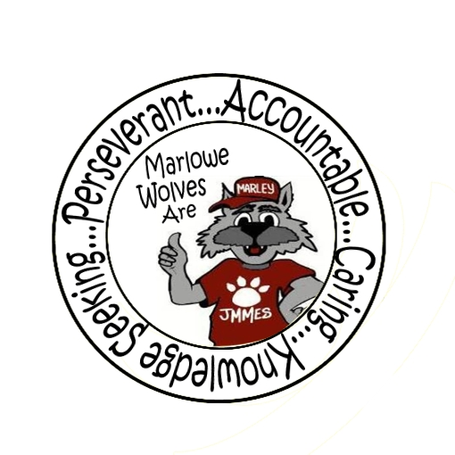



Newsletter for the Families of James M. Marlowe Elementary

Hilda Martin, Principal * Robin Fish, Asst. Principal

5642 Cecelia Drive • New Port Richey, FL • 34652 • (727) 774-8600

**JANUARY 2018**

**UPCOMING EVENTS**

January 11th – McWolf Night – Southgate – 4-7 pm

January 15th – No School – Martin Luther King Day

January 16th - Report Cards

January 18th – Parent PACK Night 6:00 pm - 7:40 pm



**TEACHER & SRP OF THE YEAR**

We are pleased to announce that our

Teacher of the Year

is ***Mrs. Brown***

and our School Related Personnel of the Year

is ***Mrs. Laurenti***!

**FAMILY PACK NIGHT**

***January 18th***

***6:00 PM – 7:40 PM***

Come join us for a night of activities focused around our P.A.C.K. Pride initiatives. Learn more about your students PBIS program and the 2nd step guidance program. Go see the Paw Point Trader Store, check out Marley Mart and stop by and talk to some local agencies that have great support programs available for our families. All students who attend this event will earn 10 Paw Points to use in the Paw Point Trader.



**S.T.E.M. Family Night**

**February 1st**



Join us for an interactive, fun hands on night for our 3rd, 4th and 5th grade families. See firsthand the concepts and elements of the S.T.E.M Fair project that your students will be working on during this quarter. Keep an eye out for a flyer coming home with all the details.



**WELCOME BACK**

We hope everyone had a relaxing Winter Break and enjoyed the time with friends and family. We wish everyone a wonderful New Year and look forward to a successful second semester. As we start the second semester, we would like to remind everyone of the importance of attendance. Please ensure that your student is on time for school and here for the entire day. This allows them to get the most from their instructional time with their teachers. The consistency and routine supports learning and promotes student self-esteem and success.



**McWOLF / McTEACHER NIGHT**

*January 11, 2018*

*4:00 pm – 7:00 pm*

*Southgate- US Highway 19*

Help raise money for the school while having a fun dinner. If you aren’t able to come inside, pick-up dinner through the drive thru!





**THANK YOU**

***Wal-Mart, Scotty’s Pizza, The American Legion Post 79, West Pasco Quilters’ Guild Inc***., ***St. Vincent DePaul Society, Mr. Wanker***

Thank you to Wal-Mart who helped support our Cookies & Milk with Santa and Scotty’s Pizza for sponsoring our Principals Banquet. Please support their businesses. Partnerships are essential to the successful implementation of many school programs.

Thank you to Mr. Wanker for his support of our Marley Mart Community Closet.

A **“BIG” Thank You** to the American Legion Post 79, West Pasco Quilters Guild, and St. Vincent de Paul for the support for our ABC program during the holiday season.



**PRE-ORDER YOUR YEARBOOK**

It’s that time of year to pre-order your Marlowe Elementary yearbook. Look for an order form to come home with your student in the next few weeks. Additional order forms will be available in the office.

**For Only $14.00 you can pre-order your yearbook.**

**After March 1st the cost will go up to $16.00.**

**Order now, so your child won’t miss out when**

**the yearbook is distributed!**

As an adult, you know how important school memories become. Don’t let your child’s memories fade; make sure you get a yearbook now!



**SCHOOL CROSSING GUARD APPRECIATION DAY**

February 2nd is School Crossing Guard Appreciation Day. Each and every school day, thousands of dedicated individuals whom we call Crossing Guards, spend countless hours assisting our children across busy street intersections as they arrive and depart from school. Crossing Guards provide an invaluable service to our communities and deserve special recognition for their tireless efforts. We would like to recognize and thank Marlowe Elementary School Traffic Control Officers, for their dedicated service to our school.  Thank you!

**District School Board of Pasco County**

Kurt S. Browning, Superintendent of Schools

7227 Land O’ Lakes Boulevard

Land O’ Lakes, FL 34638



**PARENT INFORMATION**

**BOX TOPS**

Keep up the great work of bringing in those box tops. The class that can collect the most box tops from December 1st to January 29th will win a classroom surprise! By saving your General Mills box tops, you can help our school. Thank you to all the students for the Box Tops you have been bringing in.

**STUDENT ABSENCES**

It is important that students attend school and arrive on time on a regular basis. Your child's attendance patterns often have a direct link with achievement. Absences are considered excused for the following reasons:

* Student illness
* Student medical appointment (please attempt to schedule after school hours)
* Bereavement
* Some religious observances

In the event of an absence, please send a note to your child’s teacher that includes your child’s full name, student number, teacher name, the date and reason of the absence in order to ensure our records are accurate.

**December Principal Banquet Award Winners**

Kindergarten

Iralis Penn, Ryker Lazri, Jayonnah Shawley

1st Grade

Leland Magnuson, Alena Mitchell, Cole Westrich,

Declan Brown, Hailey Trejo-Hernandez

2nd Grade

Aaron Powers, Rylee Tybor,

Nicholas Vitale, Eduardo Mayorquin

3rd Grade

Malique Gunner, Ethan Hickman, Isaiah Reese,

Marcus Coleman, Addison Westrich

4th Grade

Malik Smith, Jamal Benton, Onyx Schmidt

5th Grade

Cody Dlugosz, Zander Pelliccio,

Briaara Heerick, Dominic Nitz

**MARLOWE IS ON FACEBOOK**

Like us on Facebook! Upcoming events and information will be posted on Facebook.

<https://www.facebook.com/pages/James-M-Marlowe-Elementary/484263344997743>



# wolf-head.jpgBorder Stars2Macintosh HD:Users:marywhitehead:Desktop:13318214841422065416wolf track-th.pngMacintosh HD:Users:marywhitehead:Desktop:PB-1899J.jpgWolf Standing.jpg