Howling Herald

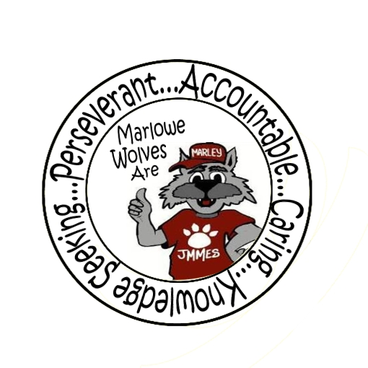



Newsletter for the Families of James M. Marlowe Elementary

Hilda Martin, Principal \* Robin Fish, Asst. Principal

5642 Cecelia Drive • New Port Richey, FL • 34652 • (727) 774-8600

**FEBRUARY 2018**





**UP COMING EVENTS**

1st – STEM Night for 4th & 5th grades

2nd – SAC Meeting 7:40 am

6th – McWolf Night 5-7pm State Road 54

7th – 13th – Valentine Day Grams Sales

9th – Progress Reports

20th – Fun with Food & Recipe Swap 6:00-7:30 pm

22nd– Spring Photos

Macintosh HD:Users:marywhitehead:Desktop:73959-Royalty-Free-RF-Clipart-Illustration-Of-A-Pink-Heart-And-Black-Scroll-Design-Border-On-A-White-Background.jpgMacintosh HD:Users:marywhitehead:Desktop:73959-Royalty-Free-RF-Clipart-Illustration-Of-A-Pink-Heart-And-Black-Scroll-Design-Border-On-A-White-Background.jpgMacintosh HD:Users:marywhitehead:Desktop:73959-Royalty-Free-RF-Clipart-Illustration-Of-A-Pink-Heart-And-Black-Scroll-Design-Border-On-A-White-Background.jpg

****

**SCHOOL CHOICE**

**Open Enrolment for 2018-2019**

The District School Board of Pasco County’s School Choice Open Enrollment initiative provides an opportunity for a Pasco County student to attend a public school outside the student’s assigned boundary area, as well as public schools in neighboring counties, as long as the requested school is not critically overcrowded. The parent/guardian of a student wishing to attend a school outside their boundary area must submit a School Choice Open Enrollment Application to the District School Board of Pasco County during the established open enrollment period. Submitting an application does not guarantee that the student will be approved to transfer to the requested school of choice. Open Enrollment applications will be accepted from **February 1 through March 1, 2018,** for the 2018-19 school year.Applications are available at the DSBPC office and online at**:**

[**http://www.pasco.k12.fl.us/ed\_choice/school\_choice/registration**](http://www.pasco.k12.fl.us/ed_choice/school_choice/registration)

**Scroll down to the end of the page and click Apply On-Line.**

If you have a student **currently** on School Choice, you do not need to reapply UNLESS: Your address changed after initial approval, you reside outside of Pasco County, if the student will be moving to the next school level (Elementary to Middle or Middle to High) or your school was impacted by a boundary change.

While the school district makes every effort to accommodate all school choice requests, many of the district schools are critically overcrowded (at or above 100% of capacity) and are deemed “frozen”. Transportation to a school that is outside the student’s attendance zone is the responsibility of the parent/guardian.

* 5th grade students will only roll over to Gulf Middle School if they are zoned for Gulf Middle.



**McWOLF / McTEACHER NIGHT**

*February 6th*

*5:00 pm – 7:00 pm*

*State Road 54*

Help raise money for the school while having a fun dinner. If you aren’t able to come inside, pick-up dinner through the drive thru!

**BOX TOPS**

Keep up the great work of bringing in those box tops. We are going to extend our Box Top contest until February 23rd. The class with the most collected will win a prize. Thank you to all the students for the Box Tops you have been bringing in.

**REMINDERS**

* Please write your students name in their coats and lunch boxes. This helps us return the items when they are left behind.
* Please remember that students should not be arriving on campus before 8:20 a.m. There is no supervision until students go to breakfast at 8:20 a.m.
* If your student is running a fever, they need to be fever free for 24 hours before returning.return to school.



**PRE-ORDER YOUR YEARBOOK**

It’s that time of year to pre-order your Marlowe Elementary yearbook. Order forms went home with your student. Additional order forms are available in the office. You can pay for your yearbook through school pay or with cash.

**For only $14.00 you can pre-order your yearbook.**

**After March 1st the cost will go up to $16.00.**

**Order now, so your child won’t miss out when**

**the yearbook is distributed!**

As an adult, you know how important school memories become. Don’t let your child’s memories fade; make sure you get a yearbook now!

**SPECIAL THANKS**

During Literacy Week in January, we celebrated with a “Starbooks” Café. We would like to thank River Crossing Starbucks for donating cups for the event, Collette Wilson for balloons and to Jackie Deck for donating books for every student. The students enjoyed their special reading time at the café!

**SPRING PHOTOS AND CLASS PHOTOS**

Spring photos and class photos are scheduled for February 22nd. Make sure to have your smiles ready. The photo proofs for both the class photo and the spring individual photo will be sent home at a later date for your preview and will be able to be ordered at that time. No order forms or money is due before picture day.

**DENTAL VAN**

Marlowe Elementary will be visited by the Mobile Dental Bus “Smile Care A Van” on February 20th, 21st, 22nd & 23rd for students in 2nd, 3rd, 4th & 5th grades. Dental services will be available at no cost. Permission is required from parent. Forms were sent home at the end of January.

**MARLOWE IS ON FACEBOOK**

Like us on Facebook! Upcoming events and information will be posted on Facebook.

<https://www.facebook.com/pages/James-M-Marlowe-Elementary/484263344997743>



**District School Board of Pasco County**

Kurt S. Browning, Superintendent of Schools

7227 Land O’ Lakes Boulevard

Land O’ Lakes, FL 34638

# images-3

# Macintosh HD:Users:mwhitehe:Desktop:th.jpg

# Macintosh HD:Users:marywhitehead:Desktop:Facebook-logo-1817834_png.jpgBorder Stars2Macintosh HD:Users:marywhitehead:Desktop:13318214841422065416wolf track-th.pngwolf-head.jpgMacintosh HD:Users:marywhitehead:Desktop:PB-1899J.jpgWolf Standing.jpg

January Principal Banquet Students

Kindergarten

John Stallings, Trevor Chyben,

Bentley Lorenzo, Dayrelis Sanchez-Albin

1st Grade

Sean Eggert, Alexi Pham, Jordan Padilla

Janiyah Torres, Hadar Byish

2nd Grade

Caezar Ramos, Nikolina Podric,

Deanna Cortes, Cimara Smith

3rd Grade

Isabella Wilton, Pharaoh Tillman,

Kaylah Taylor, Joseph Paris

4th Grade

Kihanna Webster, Lian Aniban,

Georgia Brashears

5th Grade

Alyssa Rey, Isabelle Chapman,

Shyliah Smith