Howling Herald

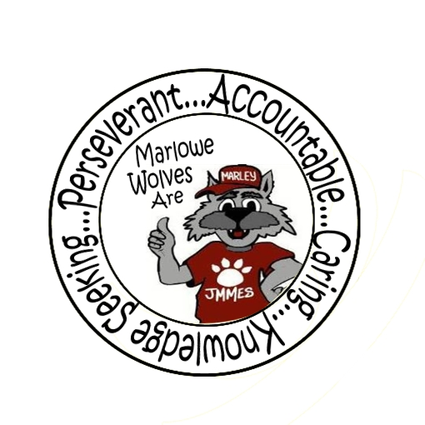



# Macintosh HD:Users:marywhitehead:Desktop:Shamrock Logo.jpg

Newsletter for the Families of James M. Marlowe Elementary

Hilda Martin, Principal * Robin Fish, Asst. Principal

5642 Cecelia Drive • New Port Richey, FL • 34652 • (727) 774-8600

**MARCH 2018**

 **FSA TESTING**

FSA testing will begin on March 5th and run through May 1st for students in grades 3, 4 and 5. Please keep in mind the following tips in order to give your child his or her best opportunity for success:

* Encourage a good night’s sleep
* Dress comfortably
* Encourage your child to read every question carefully and eliminate the known wrong answers if a question is difficult

Testing will begin each morning at 8:50, so please make every effort to arrive at school on time. It is important to note that if a student begins a session and needs to leave campus without finishing (due to an appointment, illness, etc.), he or she will not be allowed to complete that session. Please make every effort to schedule appointments on dates that are not designated as FSA testing days. Testing dates are as follows:

**March 5th**

FSA Writing – Grades 4 & 5

**April 9th & 10th April 23rd & 24th**

FSA Reading - Grades 3 FSA Reading – Grade 5

**April 16th & 17th April 25th & 26th**

FSA Math – Grade 5 FSA Reading – Grade 4 **April 18th & 19th**  **April 30th**

FSA Math – Grade 4 FSA Math – Grade 3

**May 1st** FCAT Science – Grade 5

FCAT Science – Grade 5

FSA Math – Grade 3



**UPCOMING EVENTS**

March 2nd – SAC Meeting – 7:40 am

March 8th – Skate Night – 6:30 – 8:30 pm Spinnations

March 12th – 15th - Book Fair

March 13th - Reading Under The Stars – 5:30 pm

March 16th - No School – Teacher Planning Day

March 19th – March 23rd - Spring Break – No School

March 28th – STEM Make N Take 3:00-5:00 pm

April 2nd – Report Cards



**HEAD START & EARLY HEAD START APPLICATION DAYS**

#### **No appointment needed!** **Each family must meet in person with a staff member in order to apply for Head Start/ Early Head Start. Head Start/Early Head Start is not a first come first served program. Please expect to be at an application day location for your face-to-face interview for at least 30 minutes or more.**

**District School Board Complex, (Portable 23) 8:30 a.m. - 3:00 p.m.**

7227 Land O’ Lakes Blvd. (Hwy 41) Land O’ Lakes 34638

**March 30**

**Metropolitan Ministries Outreach Center 9:00 a.m. - 3:00 p.m.**

3214 US Highway 19 Holiday 34691

**April 26**

### At the time you submit the application, you must have the minimum items: Proof of birth for all applicants, Proof of Guardianship/Kinship, Proof of residency in Pasco County, Proof of income, Applicants social security card, WIC documentation, Any disability documentation, Documentation of pregnancy if applicant is an expectant mother. Details on documentation can be found at: <http://www.pasco.k12.fl.us/ecp/required_documents>



**BOX TOPS**

Congratulations to Mrs. McKim’s class for having the most box tops in December, January & February. They have earned an ice cream party! Keep those box tops coming.





**FLORIDA’S 2017-2018 ESE PARENT SURVEY**

We need your help to make Florida’s 2017-2018 ESE Parent Survey a record success. Each year, the Florida Department of Education (FDOE) surveys parents of children with an individual educational plan (IEP) to determine how well your child’s school is partnering with you and promoting your involvement in your child’s education. All states must collect this data as part of their State Performance Plan, as required under the Individuals with Disabilities Education Act (IDEA) Make Your Voice Heard! The web-based survey is now open. You can complete the survey online at:[**http://www.esesurvey**](http://www.esesurvey.com)**.com** or request a paper survey from your child’s school. **Your feedback is important** in helping the state and local school systems continue improving educational programs for children with special needs. **Thank you!**

Necesitamos su ayuda para hacer de la Encuesta ESE 2017-20178para padres en Florida un gran éxito. Cada año el Departamento de Educación de Florida (FDOE) encuesta a los padres de niños que tienen un plan educativo individualizado (IEP) para determinar cómo la escuela se relaciona con usted y cómo promueven su participación en la educación de su niño(a). Todos los estados deben obtener esta información como parte de su Plan de Desempeño del Estado, según lo requiere la Ley de Educación de Personas con Discapacidades (IDEA). ¡Que se oiga su voz! Puede contestar la encuesta visitando: [**http://www.esesurvey**](http://www.esesurvey.com)**.com** o solicitar la encuesta en papel en la escuela de su niño. **Su opinión es importante** para ayudar a los sistemas escolares locales y estatales a seguir mejorando los programas educativos para los niños con necesidades especiales. **¡Gracias!**

**ORDER YOUR YEARBOOK**

It’s that time of year to order your Marlowe Elementary yearbook. Order forms are available in the office.

**Yearbooks are $16.00.**

Order now, so your child won’t miss out when the yearbook is distributed! As an adult, you know how important school memories become. Don’t let your child’s memories fade; make sure you get a yearbook now!

**SPRING BREAK**

Spring Break is March 19th – March 23rd. Students return to school on March 26th. There is no school on March 16th for teacher planning. We hope you enjoy your break!

**BOOK FAIR**

The Book Fair will be March 12th – 15th. Information will be coming home for the book fair. Extended hours will be available during the Reading Under The Stars.

**THANK YOU**

Partnerships are essential to the successful implementation of many school programs. Thank you to the following partners in education for their support of our school. Both the school and partners benefit from the cooperative endeavors by sharing resources that promote learning and overall school improvement. Thank you to the following for their support:

***Cracker Barrel***

Please support our partners in education!



**SKATE PARTY**

March 8th

6:30 – 8:30 pm

SPINNATIONS

Who’s ready for a skate party!

Ticket Prices: Pre-Sale $ 5.00

(March 5th, 6th 7th & 8th in the morning outside the front office)

At Door: $6 Students, $5 Skating Parents

* all prices included regular rentals, rollerblades $3 extra



7227 Land O’ Lakes Boulevard

Land O’ Lakes, FL 34638

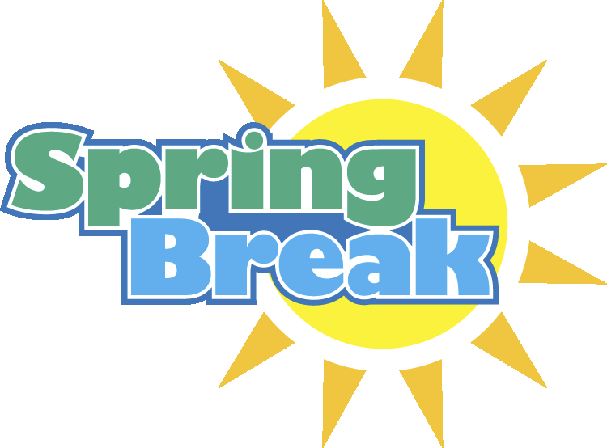

# Border Stars2Macintosh HD:Users:marywhitehead:Desktop:13318214841422065416wolf track-th.pngwolf-head.jpgMacintosh HD:Users:marywhitehead:Desktop:PB-1899J.jpgWolf Standing.jpg

February Principal Banquet Students

Kindergarten

Bethzaida Maye Zongua, Gabriel Kapucinski,

Riley Jones, Jaden Carr

1st Grade

Luciana Duke, Bilge Eti, Kevin Seago,

Sophia Epperson, Arianna Ortiz

2nd Grade

Ariana Mayar, James Pelliccio,

Gabby Skipper, Jose Gomez

3rd Grade

Autumn Parsons, Daisy Pedraza-Palma,

Dominic Carrasco, Zullymar Emigdio,

Danellys Davila-Vazquez

4th Grade

Mariam Ali, Kellyann Brooks,

Jazzy Juan Hernandez

5th Grade

Alexa Cardosa, Naishka Soto Agramonte,

Savannah Thompson, Ethan Pollard